3.GIT HOL

Step 1: Create and Work in a New Branch

Step 2: Merge Changes Back to Master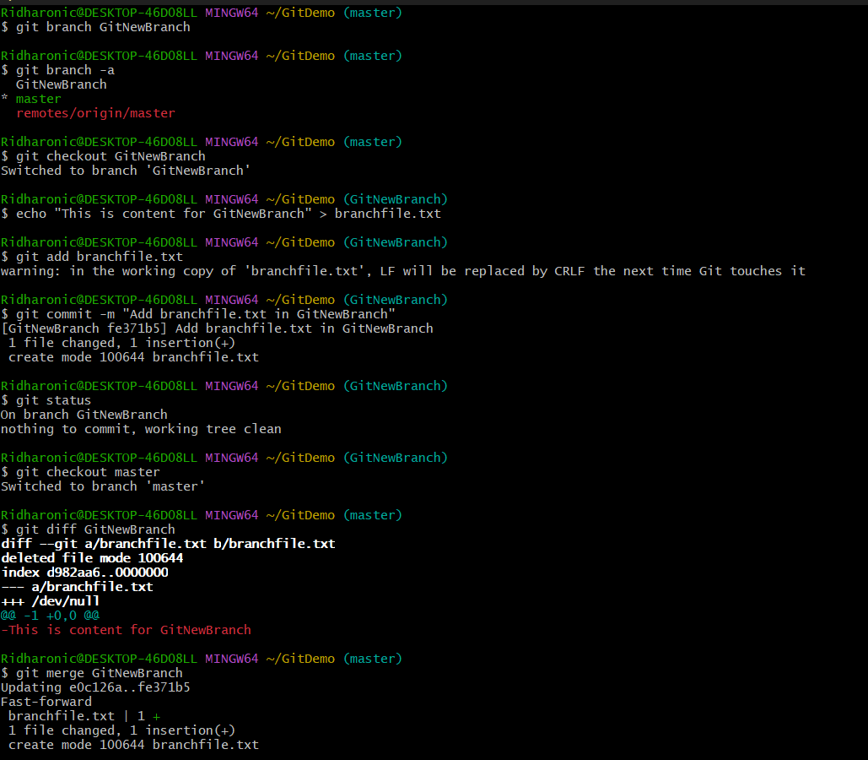

Step 3: Cleanup